ZFIVATMST – Tax code master data report

## Purpose

This report can be used to display information about tax code customizing. It is replacing standard SAP report S_ALR_87012365 which is a built in but old-fashioned way making analyses very difficult.

## Program description

Selection Screen

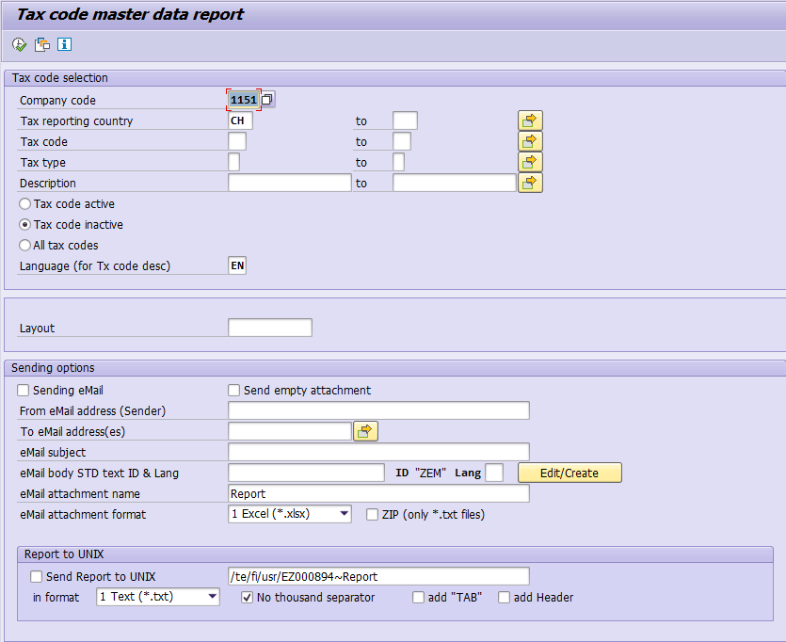

**Tax code selection**

|  |  |
| --- | --- |
| Field | Description |
| Company code | Instead of using the country we have decided to use the company code for finding the tax code master data. This was done because of several reasons:   1. Very often the company code is used for authority check 2. Tax country & tax procedure are based on the company code 3. ZFIVAT001 (Tax report with logistic) data is calling this program with company code to display tax code details   Finally, it is still very easy to find the tax codes, just select a company code from the respective country. |
| Tax reporting country | This field is used with the plant abroad functionality. Tax codes for a certain country can be setup for other countries where a legal entity is registered for VAT. This criterion can be used to display the tax codes other than the tax reporting country. Read OSS Note 63103 for more details about the plant abroad functionality. |
| Tax code | Self-explanatory |
| Tax type | ‘A’ for output tax codes or ‘V’ for input tax codes |
| Description | This field can be used to find tax codes based on their description |
| Tax code status | Select whether you want to display active, inactive or all tax codes. This flag can be set by implementing OSS Note 2074351 |
| Language | Use this value to determine the tax code description language. Default is set to English |

**Sending options**

These fields are used to send the report output via mail. Different formats can be selected, such as Excel, Text etc. You could even store the report in a UNIX directory.

The Mail text will be created through SO10 when hitting the ‘Edit/Create’ button.

Report Output

The report comes in with a handy ALV layout where you can easily apply filters, sorting & grouping criteria (standard ALV format options). Of course, the result can be easily exported to a Spreadsheet by using a right click in the report.

All fields displayed are available through transactions FTXA / FTXP which are used for individual tax code analysis.

